**A REPORT ON VIDEO GAME TRENDS**

“All work and no play makes Jack a dull boy…”. Gaming is an interesting part of life that is less recognized amongst adults. It is seen to be a thing for children because adults are acclaimed to be past that level. According to Cooper Inveen and Francis Kokoroko in 2022, 27% of Ghana’s population are active gamers (EA Sports analyst, Newzoo). The primary characteristic that sets video games apart is their interactive nature; players are not able to just follow a game's plot in a passive manner (Granic et al., 2014). Rather, players interact actively with their systems in video games, and the systems respond to the player's agentive actions (Granic et al., 2014). There are millions of video games available, with diverse themes and objectives. These games can be played on a variety of platforms, including computers, cell phones, and consoles like the Nintendo Wii and Playstation. They can be played competitively or collaboratively, alone, with other players in person, or with thousands of other players online. Owing to the wide range of genres and aspects that video games can take on, creating a thorough taxonomy of modern games is incredibly challenging (Granic et al., 2014). Video games have quite a good number of advantages as well as disadvantages. Some advantages include development of one’s mental abilities, building good social skills through communities, boosting one’s emotions and motivation. Due to the widespread effects of the corona pandemic increase, the video game business, which is estimated to be worth $159.3 billion in 2020, is projected to continue growing (Adıgüzel, 2021). Despite the fact that video games are not items like conventional commodities, producers invest more time into creation and advertisement which makes the video game industry one of the best-selling industries in the world. Gamers have become abundant on platforms like YouTube and it all counts in creating traction for the games.

This analysis studies the trends in the video game industry from 1980 till 2020, focusing mainly on sales.

Hypothesis

Businesses have come to understand the potential advantages of studying the gaming market on a global level to know their competitors, hot zones and traditional gaming communities. Most game publishers believe that the recent game rankings were based on sales and not online reviews.

METHOD;

The data was obtained from the office of Blossom Academy. The data contained 16,600 recorded rows of ranked video. Fields collected in this dataset included ranking of overall sales, the games name, platform of the games release, year of the game's release, genre of the game, publisher of the game, sales in North America (in millions), sales in Europe (in millions), sales in Japan (in millions), sales in the rest of the world (in millions), total worldwide sales. Tools used for this analysis included Microsoft Excel and Power BI.

The data analysis process was employed in unravelling this puzzle: ask, prepare, process, analyze, share, and act in order to answer the given business question.

Ask: The questions I tried to answer with this analysis are;

* Which platform is most preferred?
* Which publisher is booming?
* Which regions invest in video games the most?
* Which year did video games gain the most traction?
* Which platform hosts more video games?
* Which genre is most preferred?
* What is the most published game genre in a year?

Prepare: The data was presented as a CSV file. I resaved the file as an excel file where I make a copy of the sheets to help me better prepare the data for analysis without messing up with the original file. The duplicated file was then used for the analysis.

Process: I used Microsoft to do initial cleaning of the data and defining data types. There were no duplicates in the data. I sorted the data for blank cells and inconsistencies. I then converted all sales values to millions by multiplying them by 1,000,000. 271 rows had no date entries. I kept them anyways because they were too significant and would affect the analysis if I cleaned them out. However, 2017-2020 had not enough data to be decided on. I used them but did not take them into consideration. To be sure I recalculated the Global sales with the ‘sum’ function to make sure that the data was not false. I realized that 1153 had wrong calculated values.

Analyze: I analyzed the data with POWER BI, where I tried to answer all the initial questions I asked. I uploaded 2 tables into Power BI (sales and vgsales_final). I also created measures to help with calculations (Untallied rows, Global sales difference, No. of Publishers, Total no. of vg). I created slicers for genres and Year too.

RESULTS

Below are my reports in Power BI;

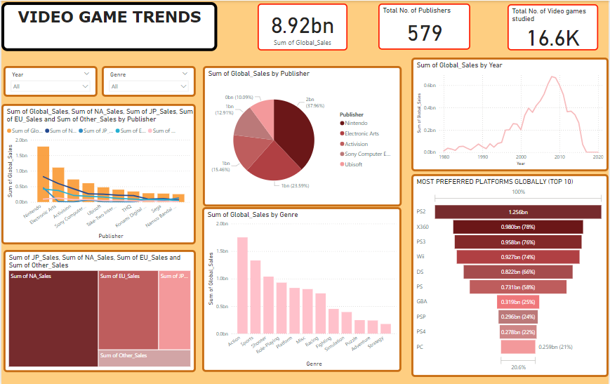\

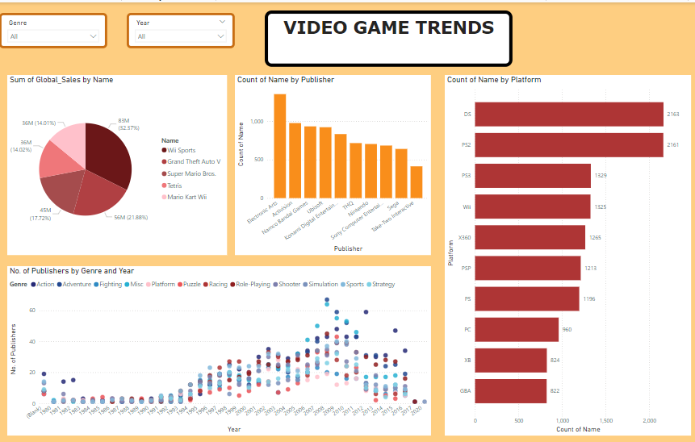

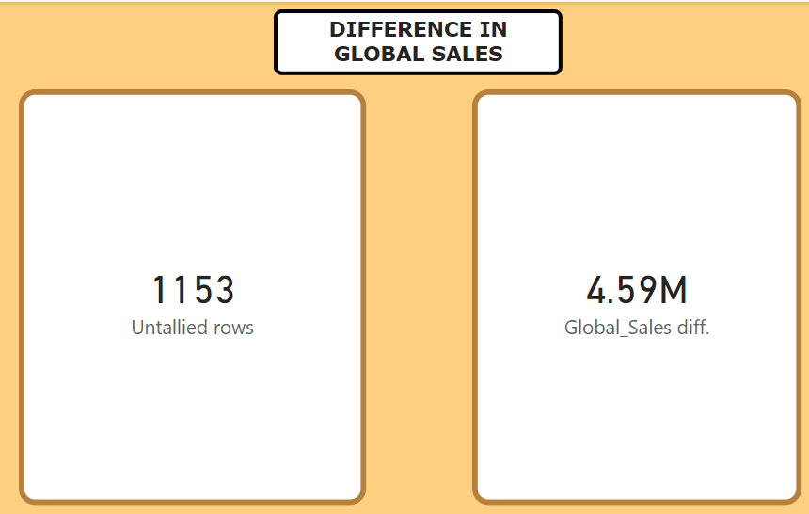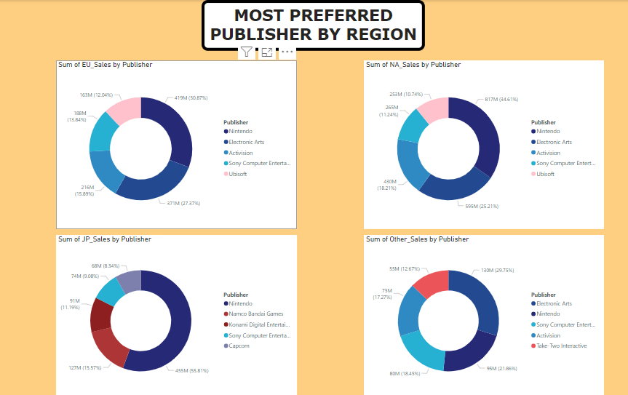

Top 10 Publishers Globally and by Region;

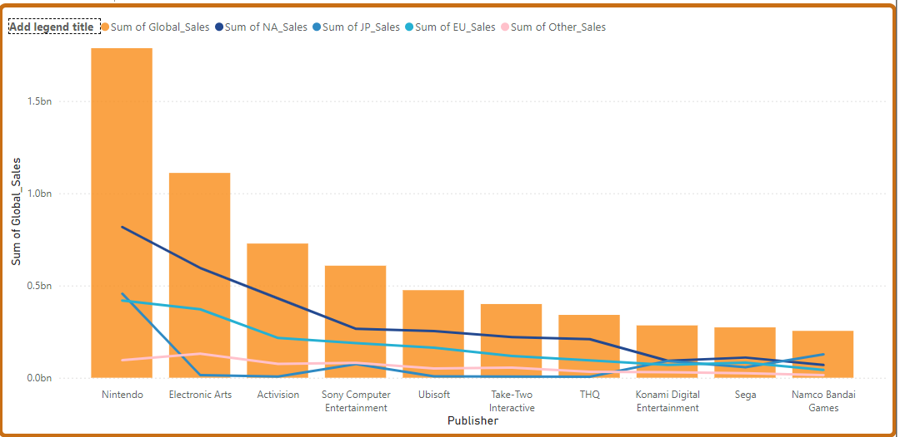

Upon plotting the Publishers by the sum of Global sales as columns and regional sales as lines, I discovered that Nintendo (1.79bn) was the highest selling publisher worldwide, followed by Electronic Arts (1.11bn), Activision (0.73bn) , Sony Computer Entertainment (0.61bn) , Ubisoft (0.47bn) , Take-Two Interactive (0.40bn) , THQ (0.34bn) , Konami Digital Entertainment (0.28bn) , Sega (0.27bn) and then Namco Bandai Games (0.25bn) respectively. Looking at it from the regional perspective, in North America, Nintendo continues to lead the market over all the other regions. This trend runs through all other regions. But I realized that for Nintendo, the Japanese produced more sales than the Europeans which could suggest that Nintendo is their home-bread Publisher. Sega also has its maximum sales in North America where it was created. This tells us that the origin of a publisher could affect its sales by number.

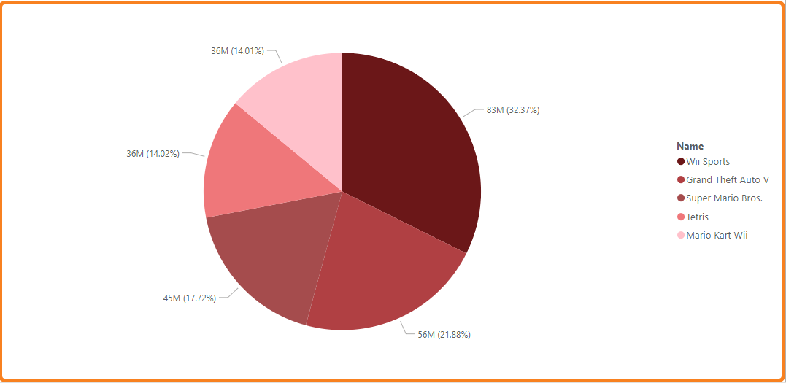

To find the top 5 games, I plotted the Name against the sum of Global sales on the pie chart and I limited the data to only show the top 5. Wii Sports topped the chart with 32.37% followed by Grand Theft Auto V (21.88%), Super Mario Bros (17.72%) , Tetris (14.02%) and Mario Kart Wii (14.01%). This information talks to us about the most played games in the most not necessarily the best but it is rather interesting to know that most of these 5 are found in the first 10 ranked games.

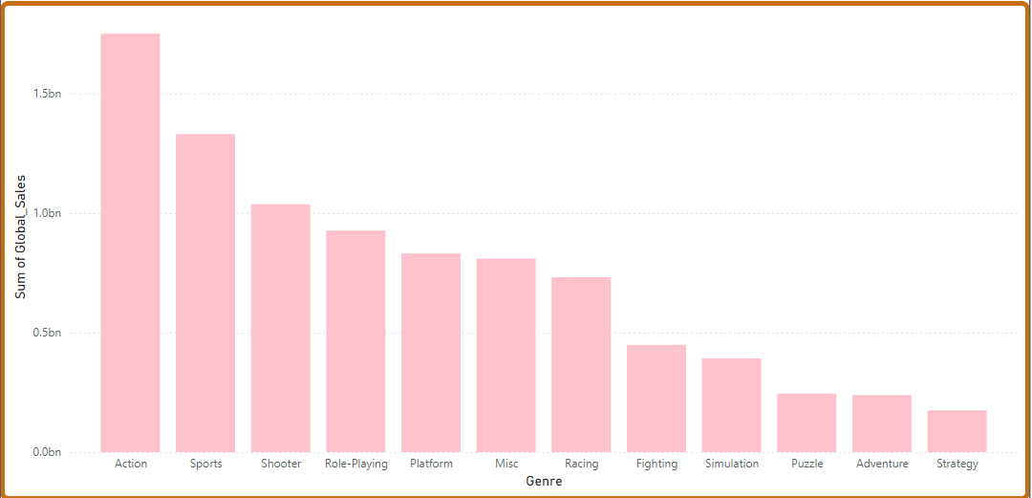

The column chart explains the most preferred genre globally. From the plot, Action games are most preferred by players and then the Sports. The least bought genre are the Strategy games. Strategy games are games that exploits the intellectual prowess of the player. Most players do not find it interesting because of the need to think deep into the game. Most people prefer direct games to that.

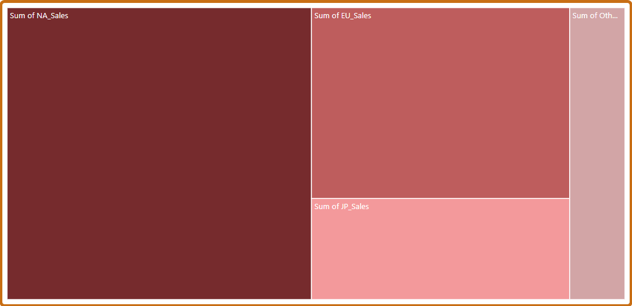

The tree map shows us the region that invests into video games the most, being, North America, Europe, Japan and other respectively.

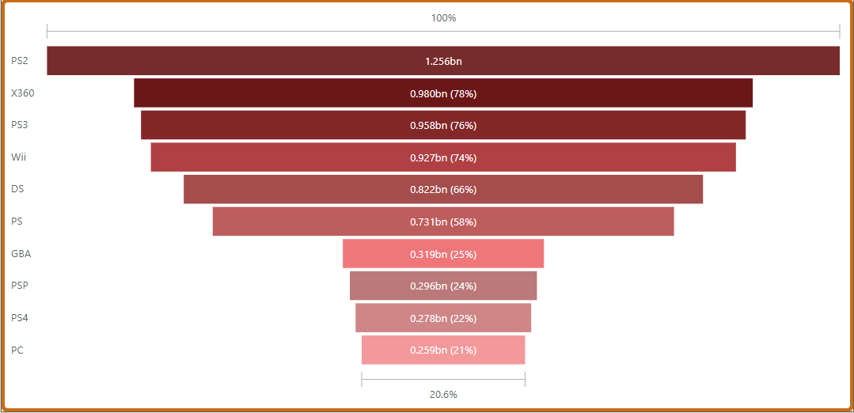

The platforms or consoles give the user the opportunity to play the various games with ease. Console comfortable and usability influences the user’s preferences. From this chart, the most preferred platform was the PS2 which had a total number of 1.256 billion sales. It was followed closely by X360 (0.98bn, 78%), PS3 (0.958bn, 76%), Wii (0.927bn, 74%), DS (0.822bn, 66%), PS (0.731bn, 58%), GBA (0.319bn, 25%), PSP (0.296bn, 24%), PS4 (0.278bn, 22%), PC (0.259bn, 21%). This is to say that as at the time the data was collected most gamers bought PS2 when it came out till the said date.

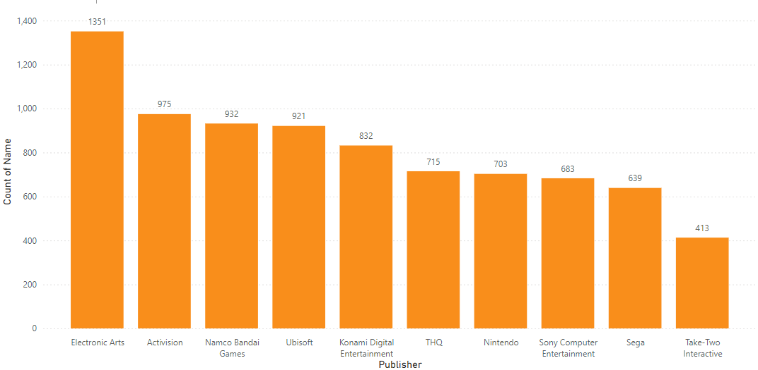

To find out the Publisher with the greatest number of games published, I plotted the Name count against the Publishers. The top 3 Publishers with most games were Electronic Arts (1351), Activision (975) and Namco Bandai Games (932). The number of games published has a good correlation with making a publisher a globally preferred publisher.

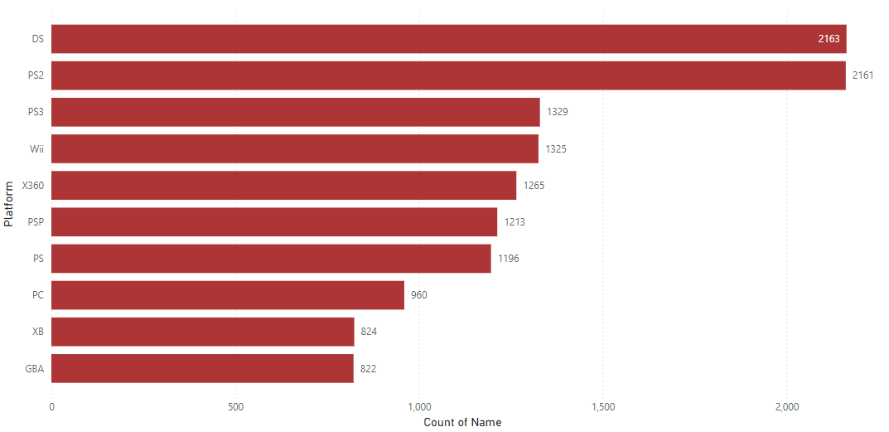

I also analyzed The Platform by Name count and I realized that the DS console had the highest number of games which was closely followed by the PS2 and then the PS3. These numbers correlated with the most preferred platforms globally.

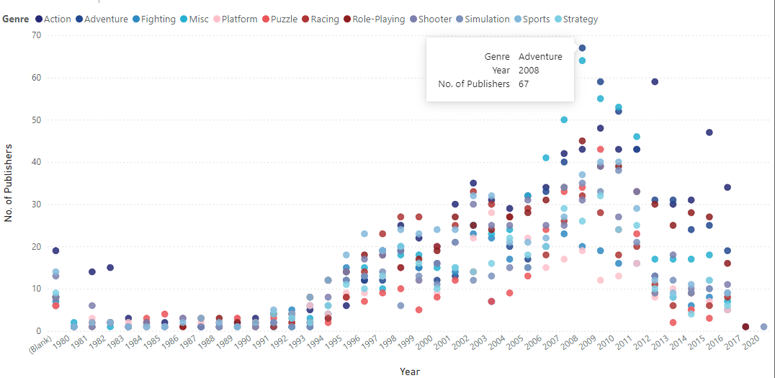

The scatter plot diagram explains the number of publishers that published a particular genre in a certain year. For example, in 2008, adventure games were published by a maximum number of 67 publishers.

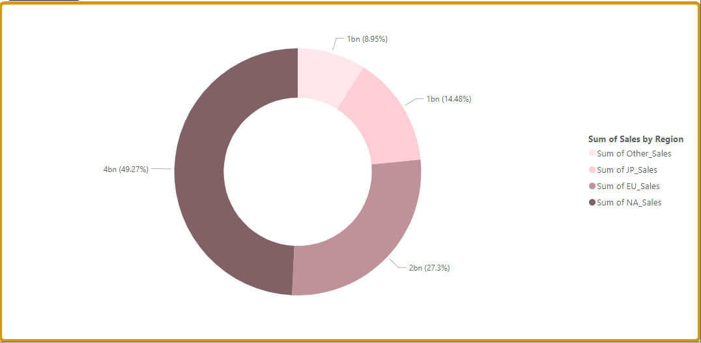

The region with the highest sales is North America (49.27%). The second is Europe (27.3%) then Japan (14.48%) and then other regions (8.95%).

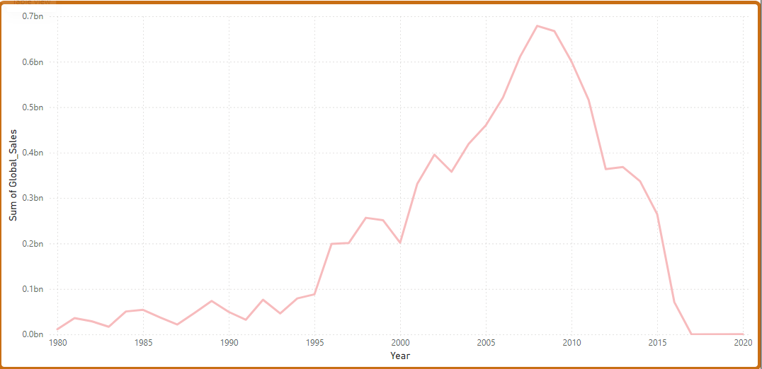

The line chart estimates the sum of global sales by the years. It shows the total number of sales in every year. From the chart, the most sales were made in 2008.

Also, I noticed some discrepancies in the dataset. I took it upon myself to recalculate the Global sales and I found out that 1153 rows were wrongly calculated which gave a difference margin of 4.59 million.

Additionally, I discovered that North America and Europe has same Publisher preferences as compared to Japan and other parts of the world.

CONCLUSION

From our data, we can conclude that popularity of a particular video game has the chances of influencing its rank. Video are a slowly growing market globally. With 49.24% of all video game sales, North America is the largest market in the world. DS and PS2 platforms host the highest number of games. Wii Sports, with a total of 83 million sales, was the best-selling game according to the data provided. With 1.79 billion sales, Nintendo accounted for 24.95% of all global sales, making it the most popular publisher. Additionally, action games are more popular than shooters and sports. Publishers are to study the market trends to know what users prefer and what they don’t.

REFERENCE

Adıgüzel, F. (2021). The Effect of YouTube Reviews on Video Game Sales. *Journal of Business Research - Turk*. https://doi.org/10.20491/isarder.2021.1249

Granic, I., Lobel, A., & Engels, R. C. M. E. (2014). The benefits of playing video games. *American Psychologist*. https://doi.org/10.1037/a0034857